Use Case Diagram

There are two types of users. One is an administrator accessing the database, and the other is a user or doctor who can log in or register by entering details and predicting risk

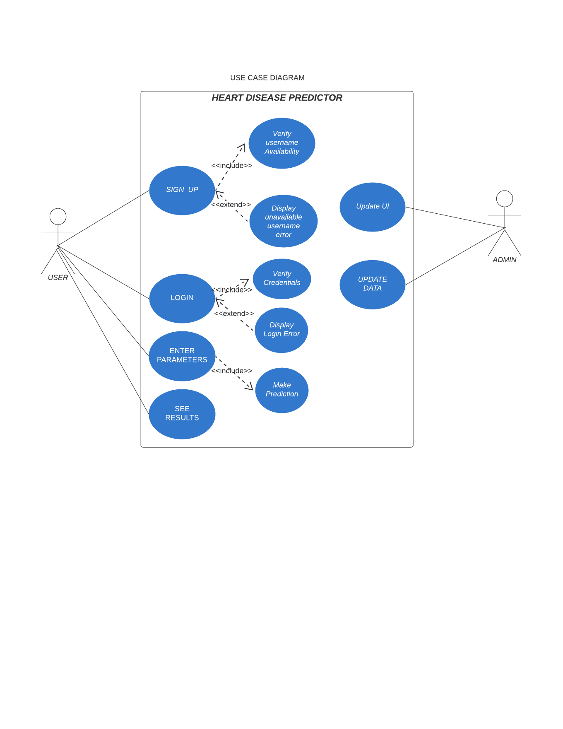

DFD Level 0

It represents how the data flows in our system. When a user sign in or logs in the user is returned by the appropriate response. Any admin can manage a user data, update the database or delete a wrong entry.

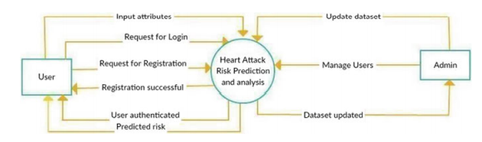

DFD Level 1

It shows details of the data flow and various entity and system functions.

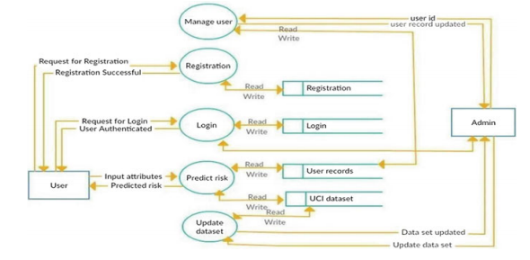

DFD Level 2

The level 2 data flow diagram shows how requests and responses are sent from the system to the user and vice versa

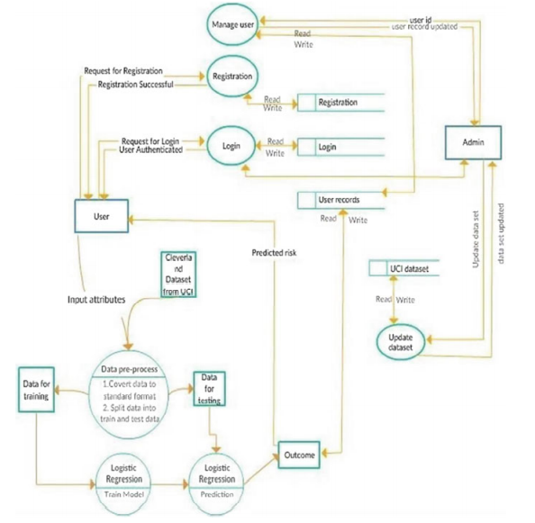

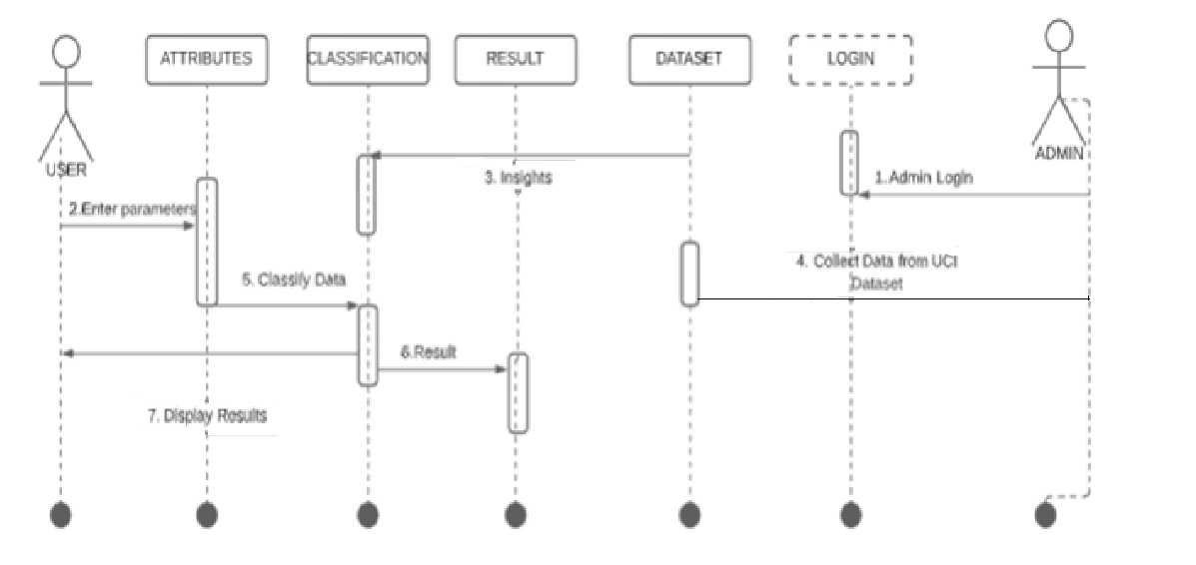

Sequence Diagram